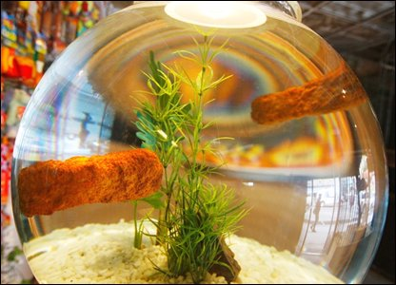

FISH FINGERS IN GOLDFISH BOWL

One day a couple of fish fingers whilst waiting be eaten decided to take a swim, so they climbed into the goldfish bowl and swam, but not for long, for they would soon be getting a call telling them it was now time to be eaten. The fish fingers, despite putting up a terrible fight got yanked out of the bowl and as they were about to be cooked they screamed.

“Shut up fish fingers shouted the man who was about to cook them, and despite their cries they got put in the oven and cooked. the cooking killed the fish fingers, this made them suitable to eat.